MELISSA LOUNGE: A CELEBRATION OF DESIGN

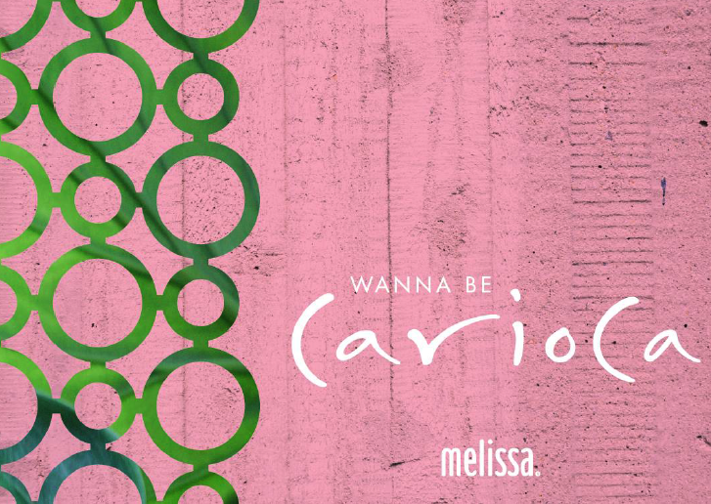
On the occasion of the Salone del Mobile 2016, Melissa, the famous footwear brand which transforms dreams into plastic along with the world’s most famous designers and stylists, will present a new initiative dedicated to all visitors and fans of the brand.
Conceived as a cozy sitting space in the Tortona area, right outside Grendene’s Italy showroom, MELISSA LOUNGE will be a contemporary space made in order to celebrate fashion, art and design during Milan’s design week. Its opening will take place on April 12th, at 6pm.
Some of the most impressive creations which are part of Melissa’s journey will be displayed as pieces of art, including pairs signed by the Campana brothers, Gaetano Pesce, Jason Wu, Jeremy Scott, Vivienne Westwood and many others.
A colorful Carioca Lounge with a sitting area will be the perfect place to chill, listen to good music, sip great cocktails and enjoy free Wi-Fi.

MELISSA LOUNGE
Via Forcella, 13
dal 12 al 17 Aprile dalle 10 am alle 20 pm
Opening: Martedi 12 Aprile – dalle 18 alle 20

https://www.facebook.com/OfficialMelissa
https://twitter.com/shoesmelissa
https://www.instagram.com/shoesmelissa/
https://www.melissa.com.br/us – new site!

For more information: Giorgiana Ravizza - info@giorgianaravizza.com

