MILAN DESIGN WEEK 2016

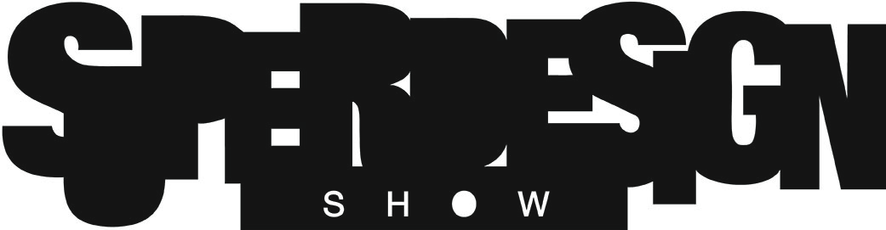

EVENT NAME: SuperDesign Show

LOCATION: Superstudio Più- Via Tortona 27 - Milan

Superstudio 13- Via Forcella 13 / Via Bugatti 9 - Milan

DATE: Press Preview 11th April 2016, 3pm-8pm (press only)

12th-15th April 2016, 10am- 9pm (professionals only)

16th April 2016, 10am- 9pm (also non-professionals)

17th April 2016, 10am- 6pm (also non-professionals)

We kindly ask exhibitors of “SuperDesign Show” to send the material required in this sheet to the following e-mail address designweek@superstudiopiu.com no later than the date indicated in the e-mail. The material will be developed and used by our Superstudio Group Communication staff.

- This Communication Form filled in every part;
- Your press release both in Italian and English in 2 different Word files (.doc or .docx);
- Pictures of the products presented at the SuperDesign Show (max. 5), in .jpg format, resolution of 300 dpi and the shortest side of at least 20 cm and relative captions. (Superstudio reserves the right to select the images put in the Press Kit).

COMMUNICATION FORM

- Contacts:
Name of the Company attending the SuperDesign Show:
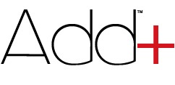
(We remind that the Name of the Company could be used for the road sign and advertising material, therefore it’s suggested to pay attention at the lettering and it’s well-recommended to state them without any kind of symbol or business model (e.g. ©,™, Ltd, Inc, etc.). In case of overlong nominatives, we’ll contact you for contingent changes)

Add+ TM

Address: 63, avenue des Champs-Elysées
Postal code: 75008 Town:Paris Country: France

Phone: +33 1 47 04 13 70 Fax:……………………………………………………………………………………
E-mail address: info@add-plus.design Website: www.add-plus.design

Press Office contact
Name: Julien Surname: Verry

Phone: 06 65 49 62 06 E-mail: attache@detachedepresse.com

Marketing office contact
Name: Katia Surname: Moisson

Phone: 01 47 04 13 80 E-mail: hello@add-plus.design

- Name and short description of the product/project both in Italian and English (300 characters each) including the name of the designer: (the text will be published in the website www.superdesignshow.com)
Italian (300 characters):Add+ è una composizione murale modulare che offre una grande varietà di scelte decorative a partire da diversi colori, materiali e funzioni.
Add + offre l’opportunità di creare un’ambiente unico con un grande livello di personalizzazione. Puoi organizzare ed modificare i moduli secondo il tuo gusto ed i tuoi bisogni.
Ti aspettiamo nella Selected Objects, dove presenteremo le nostre nuove collezioni.

English (300 characters): Add+ is a modular wall composition providing endless decorative options made of various colours, materials and functionalites. Add+ offers the opportunity to create your own environment with a high level of customization : it allows you to set-up and modify modules according to your taste and your needs. Meet us on Selected Objects area.

(Superstudio reserves the right to use this text in a short or re-edited version for communication needs)

Chiara Ferella Falda

Communication Director/Special Projects Manager
Dianora Ricca - Assistant
Via Tortona, 27 – 20144 Milano
Phone +39 02 422501- Fax +39 02 475851
designweek@superstudiopiu.com

